Left Ventricular Flow Energetics in Aortic Stenosis Using 4D-Flow Cardiovascular Magnetic Resonance: An Exploratory Retrospective Comparative Analysis

Abstract

Background
Aortic stenosis (AS) is associated with altered left ventricular (LV) haemodynamics, but conventional measures provide limited information about intracavitary flow. Four-dimensional flow cardiovascular magnetic resonance (4D-flow CMR) enables assessment of complementary flow-energetic parameters, including kinetic energy, vorticity and energy loss. However, evidence comparing these parameters within the LV in AS and control cohorts remains limited. This study investigated differences in LV flow energetics between participants with AS and a control cohort.

Methods
This retrospective exploratory comparative analysis included five participants with AS and five control participants derived from pre-existing PREFER-CMR registry datasets. 4D-flow CMR data were analysed using MASS to derive LV kinetic energy, vorticity and energy loss across the full cardiac cycle (FullRR) and predefined systolic, diastolic, E-wave and A-wave intervals. LV end-diastolic volume (EDV), end-systolic volume, stroke volume and left ventricular ejection fraction (LVEF) were also derived from the MASS workflow. Between-group comparisons used independent-samples t-tests or Mann–Whitney U tests according to data distribution, with Welch’s unequal-variance test examined as a sensitivity analysis for all independent-samples t-test comparisons. Fifteen between-group comparisons were performed without multiplicity correction, using p < 0.05 as the nominal significance threshold.

Results
LV vorticity was higher in AS during the FullRR and systolic intervals. FullRR vorticity was 315.10 ± 59.91 s⁻¹ in AS versus 239.22 ± 27.01 s⁻¹ in controls (mean difference −75.87 s⁻¹, 95% CI −143.65 to −8.10; p = 0.033; Hedges’ g = −1.474), while systolic vorticity was 308.67 ± 44.46 s⁻¹ versus 237.33 ± 34.49 s⁻¹, respectively (mean difference −71.34 s⁻¹, 95% CI −129.37 to −13.31; p = 0.022; Hedges’ g = −1.619). These remained significant in Welch’s sensitivity analysis (p = 0.045 and 0.023, respectively). Vorticity differences were not statistically significant during the diastolic (p = 0.100), E-wave (p = 0.079) or A-wave (p = 0.254) intervals. EDV-normalised kinetic energy and LV energy loss were numerically higher in AS across all five intervals, but none of the between-group comparisons reached statistical significance. AS participants had lower stroke volume (78.2 vs 88.5 mL) and LVEF (46.0% vs 54.9%) than controls.

Conclusion
LV vorticity was higher in AS during the FullRR and systolic intervals, whereas EDV-normalised kinetic energy and LV energy loss did not show statistically significant between-group differences. The higher vorticity in AS occurred despite lower stroke volume and LVEF, suggesting that the observed difference was not simply explained by greater forward flow volume or ventricular systolic function. The FullRR and systolic vorticity findings represent related measurements from the same velocity field rather than independent confirmations. Given the small cohort, baseline imbalance, clinical heterogeneity of the control group, selection of pre-existing registry datasets, inability to independently verify the absence of AS in the control group, single-centre provenance and lack of multiplicity correction, these findings are exploratory and do not establish a disease-specific or clinically applicable flow marker. Larger prospective, multicentre studies with clearly defined control eligibility, standardised acquisition and reproducible analysis are required.
Keywords: Aortic stenosis; 4D-flow CMR; left ventricular flow; flow energetics; vorticity; kinetic energy; energy loss.

List of Abbreviations:
Abbreviation | Expansion
4D-flow CMR | four-dimensional flow cardiovascular magnetic resonance
AF | atrial fibrillation
AR | aortic regurgitation
AS | aortic stenosis
AVA | aortic valve area
BMI | body mass index
CI | confidence interval
CMR | cardiovascular magnetic resonance
COPD | chronic obstructive pulmonary disease
ECG | electrocardiographic
EDV | end-diastolic volume
ESV | end-systolic volume
FOV | field of view
FullRR | full cardiac cycle
GRAPPA | generalised autocalibrating partially parallel acquisition
IHD | ischaemic heart disease
IQR | interquartile range
KE | kinetic energy
LV | left ventricular
LVEF | left ventricular ejection fraction
LVOT | left ventricular outflow tract
NNUH | Norfolk and Norwich University Hospital
NYHA | New York Heart Association
PV | pressure–volume
PVA | pressure–volume area
REC | Research Ethics Committee
R–R | R-wave to R-wave interval
SD | standard deviation
TE | echo time
TR | repetition time
TTE | transthoracic echocardiography
VENC | velocity encoding

1. Introduction

1.1 Aortic stenosis and left ventricular haemodynamic burden
Aortic stenosis (AS) is a progressive valvular heart disease characterised by narrowing of the aortic valve and obstruction to left ventricular (LV) outflow. Increasing valvular obstruction imposes a chronic pressure load on the LV, which initially adapts through structural and functional remodelling to maintain cardiac output. Persistent pressure overload can result in LV hypertrophy, impaired relaxation and progressive myocardial dysfunction. Adverse ventricular remodelling may develop before a substantial reduction in left ventricular ejection fraction (LVEF), meaning that preserved systolic function does not necessarily indicate an absence of ventricular consequences.¹
Assessment of AS severity is primarily based on transthoracic echocardiography (TTE), using peak aortic jet velocity, mean transvalvular pressure gradient and aortic valve area (AVA). These measurements remain central to clinical decision-making but are subject to recognised methodological limitations. Doppler-derived velocity depends on alignment between the ultrasound beam and the direction of blood flow, while calculation of AVA depends on measurement of the LV outflow tract. Complex or eccentric flow jets can therefore introduce measurement uncertainty. Discordance between AVA, peak velocity and mean gradient may also occur, particularly when flow conditions or other haemodynamic factors influence the relationship between valve area and transvalvular gradient.¹ Pressure recovery can further contribute to differences between Doppler-derived and invasive pressure measurements.²
The haemodynamic consequences of AS extend beyond measurement of the stenotic valve itself. During ventricular ejection, blood accelerates and converges towards the narrowed valve orifice, while chronic pressure overload can alter LV geometry and filling. These changes may influence the organisation and energetic characteristics of blood flow within the LV. Characterising intraventricular flow may therefore provide a complementary description of the haemodynamic consequences of AS.³

1.2 4D-flow CMR and assessment of left ventricular flow
Four-dimensional flow cardiovascular magnetic resonance (4D-flow CMR) is a time-resolved three-dimensional phase-contrast technique that measures blood velocity in three spatial directions throughout the cardiac cycle. The resulting velocity field provides information about the spatial and temporal organisation of blood flow and permits retrospective interrogation of different regions and planes within the acquired volume.⁴
4D-flow CMR has been investigated as a complementary approach to conventional echocardiographic assessment of AS. Studies have shown that 4D-flow CMR can quantify aortic flow velocity and pressure gradients while providing additional information about the three-dimensional characteristics of stenotic flow.^{5,6} Unlike Doppler echocardiography, 4D-flow CMR is not dependent on alignment with a predefined ultrasound beam and can characterise flow regardless of its spatial orientation. However, 4D-flow measurements remain influenced by acquisition and post-processing factors, including spatial and temporal resolution, velocity encoding and characteristics of the velocity field.⁴ Published work has demonstrated sensitivity of 4D-flow-derived energetic measurements to spatial resolution, while scan-rescan studies have evaluated the reproducibility of LV kinetic energy, viscous energy loss and vorticity measurements.^{7,8} Differences between Doppler echocardiography and 4D-flow CMR may also occur because the two techniques use different acquisition principles and are subject to different methodological limitations.^{5,6,9}
The PREFER-CMR registry has investigated the application of 4D-flow CMR in AS. Grafton-Clarke et al. studied 30 patients with AS who underwent TTE and 4D-flow CMR and reported that 4D-flow-derived peak aortic velocity was associated with subsequent aortic valve intervention, whereas the corresponding Doppler-derived measure did not demonstrate the same association.⁹ These findings suggest that 4D-flow CMR may provide complementary haemodynamic information in AS, particularly when conventional measurements are discordant. However, the published analysis focused primarily on aortic haemodynamics and used a different post-processing approach from the MASS-based analysis undertaken in the present study. The present analysis therefore examined LV flow energetics within a subset of the available AS datasets.
An important advantage of 4D-flow CMR is that the same three-directional velocity dataset can be used to investigate LV blood flow across the cardiac cycle. This provides an opportunity to derive multiple complementary measures of intracavitary flow organisation and energetics from a common velocity field.

1.3 Left ventricular flow energetics
Three complementary flow-energetic measures were considered in the present study: kinetic energy, vorticity and energy loss. These measures describe different aspects of intracardiac flow and were therefore considered separately across the cardiac cycle.
LV blood-flow kinetic energy describes the energy associated with the movement of blood within the ventricular cavity and can be derived from the measured velocity field. Normalisation to LV end-diastolic volume (EDV) can account for differences in ventricular size when comparing kinetic energy between individuals. Elhawaz et al. investigated LV blood-flow kinetic energy in 18 patients with severe AS undergoing valve intervention and reported associations between kinetic-energy measures, functional capacity and subsequent LV remodelling.¹⁰ The use of EDV-normalised kinetic energy in the present study allows comparison with previous work using a similar normalisation approach.
Vorticity provides a complementary description of blood-flow organisation by characterising local rotational motion within the velocity field. Because vorticity is derived from spatial velocity gradients, it can capture local flow structures that may not be apparent from scalar measures of velocity or kinetic energy. Rotational flow may occur during both ventricular filling and ejection and may be influenced by ventricular geometry, loading conditions, stroke volume, intracavitary flow patterns and concomitant valvular regurgitation.
Previous studies have demonstrated altered LV vorticity in other cardiovascular and cardiopulmonary conditions. Schäfer et al. reported reduced LV diastolic vorticity in patients with mild-to-moderate chronic obstructive pulmonary disease.¹¹ Demirkiran et al. reported lower mean and peak LV vorticity in patients with chronic myocardial infarction compared with controls, with regional differences according to LV thrombus status.¹² These findings demonstrate that LV vorticity can be quantified using 4D-flow CMR, although the reported abnormalities differ according to disease and cardiac phase. Evidence specifically addressing LV vorticity in AS remains limited.
Energy loss represents the rate at which mechanical energy is dissipated within blood flow. Different 4D-flow approaches have been developed to quantify energy-loss-related parameters, including viscous energy loss and turbulent kinetic energy-related measures.^{13,14} These approaches are methodologically distinct, and the present study reports a MASS-derived energy-loss measure without assuming that it represents a specific physical component such as viscous or turbulent energy loss. Evidence describing LV energy loss in AS compared with a control group remains limited.
Together, kinetic energy, vorticity and energy loss provide complementary measures of LV flow behaviour.
Pressure-volume (PV) loop analysis provides another framework for evaluating ventricular energetics, including stroke work and pressure-volume area. These measures describe myocardial mechanical energetics and are conceptually distinct from blood-flow energetic measures derived from 4D-flow CMR.¹⁵ Non-invasive approaches have been developed to estimate PV loops using CMR-derived LV volume curves and brachial blood pressure.¹⁶ Although these measures are physiologically related to blood-flow energetics, they are not interchangeable. The original research proposal included a PV-loop component; however, this component was not completed in the present study. The completed analysis therefore focuses exclusively on blood-flow energetic measures derived from 4D-flow CMR.

1.4 Knowledge gap and study rationale
Despite increasing application of 4D-flow CMR in AS, much of the existing literature has focused on aortic haemodynamics, transvalvular flow and post-stenotic flow patterns.^{3,5,6,9,13,14} Comparatively less is known about how AS influences the organisation and energetic characteristics of blood flow within the LV.
There remains limited evidence examining kinetic energy, vorticity and energy loss together within the LV in participants with AS compared with a control group. The present study therefore undertook an exploratory comparison of these LV flow-energetic parameters between participants with AS and a control group using existing 4D-flow CMR datasets.
The AS and control datasets were derived from the PREFER-CMR registry, as confirmed by the supervisory research team. The AS datasets form part of the cohort reported by Grafton-Clarke et al., who analysed 30 participants with AS from the registry.⁹ Ten control datasets from the same registry were available for the present analysis, although these control datasets have not been reported in a published study. Five AS datasets and five control datasets were included in the present exploratory analysis. The control cohort was not assumed to represent a uniformly healthy volunteer population. AS severity was not used as an eligibility criterion or for selection or stratification in the present analysis.
Given the small analysed sample, the study was exploratory and hypothesis-generating rather than designed to establish diagnostic thresholds, relationships with AS severity or clinical utility. The findings are intended to provide preliminary evidence and methodological insight that may inform larger studies using standardised acquisition, participant selection and flow-analysis methods.

1.5 Aim
To assess differences in left ventricular flow energetics between participants with aortic stenosis and a control group using 4D-flow cardiovascular magnetic resonance.

1.6 Objectives
- To quantify left ventricular flow-energetic parameters, namely EDV-normalised kinetic energy, vorticity and energy loss, using 4D-flow CMR in participants with aortic stenosis and a control group.
- To compare these parameters between the aortic stenosis and control groups across the full cardiac cycle and predefined cardiac phases.
1.7 Hypothesis
It was hypothesised that left ventricular flow energetics would differ between participants with aortic stenosis and a control group.

2. Methods
2.1 Study design and setting
This was an exploratory retrospective comparative analysis of existing cardiovascular magnetic resonance (CMR) data comprising five participants with aortic stenosis (AS) and five control participants. The analysis was undertaken at Norfolk and Norwich University Hospital (NNUH), Norwich, UK, using pre-existing datasets from the PREFER-CMR registry. The registry contains both AS and control arms, as confirmed by the supervisory research team. The five AS datasets analysed in the present study formed part of the AS cohort reported in the published PREFER-CMR study,⁹ whereas the control datasets analysed here have not been reported in a published study.
The published PREFER-CMR study reported 30 participants with AS.⁹ Ten control datasets were available from the registry, of which five were analysed in the present study. The precise historical mechanism by which the analysed datasets were selected from the available datasets could not be independently established from the records available to the researcher and was therefore not described as random, consecutive or formally matched. The reduction to five participants per group reflected the practical constraints associated with CMR contouring, quality control and 4D-flow analysis within the dissertation timeframe.
The present analysis focused on left ventricular (LV) blood-flow energetics derived from four-dimensional flow CMR (4D-flow CMR), specifically kinetic energy (KE), vorticity and energy loss. The published PREFER-CMR study investigated 4D-flow CMR-derived aortic haemodynamic measures in AS; the present study used the existing registry datasets for a secondary analysis of LV flow-energetic parameters.⁹
Non-invasive pressure-volume (PV) loop reconstruction formed part of the original research proposal but was not completed within the dissertation timeframe. Consequently, PV-loop-derived stroke work, pressure-volume area (PVA) and myocardial efficiency were not included among the completed analyses.
The study was single-centre, as both analysed groups were derived from the PREFER-CMR registry at NNUH.

2.2 Study population

2.2.1 Aortic stenosis cohort
The published PREFER-CMR study included adults with AS diagnosed by transthoracic echocardiography (TTE). Participants with contraindications to CMR, including incompatible implanted defibrillators, claustrophobia and estimated glomerular filtration rate <30 mL/min/1.73 m², were excluded. Participants who had undergone previous surgical or transcatheter aortic-valve intervention were also excluded. Atrial fibrillation (AF) was not an exclusion criterion.⁹
Five AS datasets were included in the present analysis. The datasets were selected from the available PREFER-CMR AS dataset within the practical constraints of the dissertation. AS severity was not used as an eligibility criterion or for selection or stratification in the present analysis. The selection process may therefore represent a potential source of selection bias.
Baseline demographic and clinical characteristics for the AS participants were obtained from the available PREFER-CMR clinical dataset.
No independent echocardiographic or CMR reassessment of AS severity was undertaken as part of the present analysis. Severity-related variables reported in the Results were obtained from the available PREFER-CMR clinical dataset. These included CMR-derived peak aortic velocity, echocardiographic peak aortic velocity, mean transvalvular pressure gradient and aortic valve area (AVA). AVA was taken from the AVA_VTI field in the source dataset. Because the timing of echocardiographic and CMR examinations was not identical for all participants, these measurements were not treated as contemporaneous measurements for formal reassessment of AS severity.
The analysed cohort included participants with documented concomitant valvular abnormalities. Aortic regurgitation (AR) was recorded descriptively from the available PREFER-CMR clinical dataset; among the five analysed participants, AR was nil in two and mild in three, with no mild-to-moderate AR recorded. Concomitant valve disease was therefore retained as a clinical characteristic rather than used as an exclusion criterion.

2.2.2 Control cohort
Ten pre-existing control datasets from the PREFER-CMR registry were available to the research team, as confirmed by the supervisory research team. Five control datasets were analysed in the present study. The control participants were not prospectively recruited specifically for this dissertation.
The control datasets represented the registry control arm rather than a separately recruited healthy-volunteer cohort. The control participants had undergone CMR as part of the registry framework and therefore did not have an absolute contraindication to undergoing CMR.
Available baseline information included age, sex, height, weight, body mass index (BMI), New York Heart Association (NYHA) functional class, breathlessness, oedema, hypertension, diabetes mellitus, AF, ischaemic heart disease (IHD), chronic obstructive pulmonary disease (COPD) and smoking status. Three of the five controls were recorded as NYHA functional class I and two as class II. Two controls had documented AF and two had documented oedema. One control was recorded as a current smoker and one as an ex-smoker. These observations indicate that absence of symptoms, AF, oedema or smoking was not a defining requirement for the analysed control group. Hypertension, diabetes mellitus, IHD and COPD were absent in the five analysed controls; these observed characteristics were not interpreted as evidence of formal exclusion criteria.
The control cohort was not assumed to represent a uniformly healthy volunteer population. The operational criteria by which absence of AS was originally established for the registry control arm could not be independently verified from the records available to the researcher. No independent echocardiographic or CMR reassessment of AS status was undertaken as part of the present analysis. No valve-related measurements were available for the control datasets in the source data, including CMR-derived peak aortic velocity, echocardiographic peak aortic velocity, mean transvalvular gradient, AVA or AR status.
Smoking status was reported according to the information available in the source datasets. The control dataset distinguished current smoking, ex-smoking and never-smoking, whereas the AS source variable was recorded as a binary field; these variables were therefore reported descriptively rather than assumed to represent identical definitions across groups.

2.2.3 Dataset requirements and shared CMR-derived measures
For inclusion in the present flow-energetic analysis, the selected datasets had to contain an available 4D-flow CMR acquisition covering the LV and cine imaging adequate for LV endocardial contouring. The datasets also required sufficient image quality for contour review and extraction of the predefined flow-energetic measurements. The three flow-energetic outcomes had to be available across the five predefined cardiac intervals for inclusion in the comparative analysis. These requirements describe the characteristics of the datasets analysed and should not be interpreted as the historical eligibility criteria used to select participants into the PREFER-CMR registry.
CMR-derived LV end-diastolic volume (EDV), end-systolic volume (ESV), stroke volume and left ventricular ejection fraction (LVEF) were obtained from the MASS analyses performed during the present study for both groups. LV mass was not available from the MASS analysis for either group and was therefore not included as a comparative CMR variable.

2.3 CMR acquisition
For the AS datasets, the CMR acquisition methodology was based on the published PREFER-CMR protocol, as confirmed by the supervisory research team.⁹ The published protocol used a 1.5-T Siemens Magnetom Sola scanner (Siemens Healthineers, Erlangen, Germany) with BioMatrix Body 18 coil technology.⁹
Cine imaging was performed using balanced steady-state free-precession imaging in standard long-axis views and a contiguous short-axis stack covering the LV. Cine imaging was acquired during an end-expiratory breath-hold. Reported cine parameters included TR 2.71 ms, TE 1.13 ms, field of view (FOV) 360 × 289 mm², flip angle 80°, slice thickness 8 mm and GRAPPA acceleration factor 2.⁹
The 4D-flow acquisition comprised a three-dimensional axial volume covering the thoracic aorta, with retrospective ECG gating and free breathing. Thirty cardiac phases were reconstructed with a temporal resolution of 40 ms. Reported acquisition parameters included TR 4.98 ms, TE 1.13 ms, FOV 200 × 256 mm², flip angle 5° and GRAPPA acceleration factors of 2 in the phase-encoding direction and 1 in the slice direction.⁹
The same published PREFER-CMR acquisition protocol was used for the control datasets included in the present analysis, according to protocol information confirmed by the supervisory research team.
The available project information indicated an initial velocity-encoding (VENC) setting of 150–200 cm/s. Individual final VENC values for each analysed dataset were not available to the researcher. VENC was therefore not treated as a dataset-specific analytical variable.
The published PREFER-CMR paper did not report the acquired spatial voxel size for the 4D-flow sequence.⁹ Consequently, no specific voxel dimension is reported here as an acquisition parameter.
The published PREFER-CMR analysis used CVI42 version 5.14 for its original 4D-flow post-processing.⁹ The present study used MASS for the secondary LV flow-energetic analysis.

2.4 LV segmentation and contouring
LV segmentation was performed using MASS V2025-EXP. AI-assisted contouring was initially used to generate the LV contours, after which the contours were manually reviewed and corrected by the researcher where necessary.
The LV endocardial contour was used to define the LV blood-pool region of interest for the subsequent flow-energetic analysis. Epicardial contours were generated during the image-analysis workflow but were not used in the 4D-flow blood-pool measurements.
The papillary muscles were included within the LV endocardial contour and therefore within the defined LV blood-pool region. This approach was applied consistently across all analysed datasets. This differs from previous 4D-flow CMR work in AS in which papillary muscles were excluded from the LV blood-pool contour.¹⁰
The researcher was aware of group allocation during contour review. Dr Rui Li subsequently performed quality-control review of the contours. The available records do not document whether this supervisory review was blinded to group allocation or whether all ten datasets were reviewed using a formal blinded procedure.
Particular attention was given to the basal LV contour and exclusion of the aortic valve/LVOT region from the analysed LV volume. The contours were reviewed and corrected where necessary before extraction of the flow-energetic measurements. No formal intra-observer or inter-observer reproducibility assessment was undertaken.

2.5 4D-flow CMR analysis
The 4D-flow datasets were analysed using MASS V2025-EXP. Three LV blood-flow energetic parameters were assessed:
- EDV-normalised kinetic energy.
- vorticity.
- energy loss.
Each parameter was assessed across five predefined cardiac intervals:
- FullRR.
- systole.
- diastole.
- E-wave.
- A-wave.
The cardiac intervals were defined within the MASS analysis workflow and applied consistently across the analysed datasets. The resulting phase-specific measurements were extracted for statistical analysis. All selected datasets had complete outcome measurements for the three parameters across the five predefined intervals; therefore, no outcome data imputation was required.
Before statistical analysis, the exported dataset was checked for participant allocation, outcome parameter, cardiac phase and measurement units.

2.6 Flow-energetic outcome measures

2.6.1 EDV-normalised LV kinetic energy
LV blood-flow kinetic energy was calculated within the LV endocardial region and normalised to LV EDV using the MASS built-in “Normalized by EDV” option. This normalisation procedure was applied to both AS and control datasets. The resulting values were expressed as µJ/mL.

2.6.2 LV vorticity
Vorticity was assessed within the LV endocardial region using the MASS 4D-flow analysis and expressed in s⁻¹. The reported value represented the LV-region summary generated by MASS for each predefined cardiac interval. The available project documentation does not provide a sufficiently detailed software definition to independently characterise the reported value as peak, volume-integrated or another specific vorticity metric; therefore, it is reported using the MASS parameter terminology.

2.6.3 LV energy loss
LV energy loss was obtained from the MASS 4D-flow analysis and expressed in µW. The exact mathematical formulation implemented by the MASS energy-loss parameter was not independently established from the available project documentation. The parameter was therefore retained using the software-generated terminology rather than being reclassified as viscous energy loss or turbulent kinetic energy.

2.7 Statistical analysis
Statistical analyses were performed using IBM SPSS Statistics version 32. The final analytical dataset comprised five AS participants and five controls. Given the small sample size, the analysis was exploratory and hypothesis-generating.
Three flow-energetic outcomes were assessed across five predefined cardiac intervals, resulting in 15 planned between-group comparisons.
Continuous variables were assessed using descriptive statistics and graphical assessment of distribution. The Shapiro–Wilk test was used to assess normality. Independent-samples t-tests were used for approximately normally distributed outcomes. Welch's t-test was examined as a sensitivity analysis for all independent-samples t-test comparisons. The Mann–Whitney U test was used for the diastolic and A-wave kinetic-energy comparisons.
Diastolic kinetic energy showed evidence of non-normality in the control group on Shapiro–Wilk testing (p = 0.004), whereas the corresponding AS result was p = 0.382. For A-wave kinetic energy, Shapiro–Wilk testing gave p = 0.057 in controls and p = 0.065 in AS; these borderline distributional findings, together with graphical assessment, supported use of the non-parametric test for this comparison.
Variables analysed using parametric tests were summarised as mean ± standard deviation (SD), whereas variables analysed using the Mann–Whitney U test were summarised as median (interquartile range, IQR).
Between-group differences were reported with two-tailed p values and 95% confidence intervals (CIs), where applicable. The nominal statistical significance threshold was p < 0.05.
Hedges' g was used as the standardised effect-size measure for independent-samples t-test comparisons because of the small sample size. No rank-biserial correlation was reported for the Mann–Whitney U comparisons.
No formal adjustment for multiple comparisons was applied. The five cardiac-phase measurements represent related components of the cardiac cycle, and FullRR encompasses the systolic and diastolic periods. The 15 comparisons were therefore not treated as fully independent observations.
One AS participant and two control participants had documented AF. AF was considered when interpreting phase-specific measurements because beat-to-beat variation and R-to-R variability may affect 4D-flow measurements through averaging across cardiac cycles, particularly for time-resolved flow measurements.⁹
Baseline demographic and clinical characteristics were summarised descriptively. No formal statistical hypothesis testing of baseline characteristics was undertaken because of the small sample size and the exploratory purpose of the study.
For AS haemodynamic descriptors, descriptive measures were reported using the available number of participants for whom each parameter was recorded. Mean transvalvular pressure gradient was available for all five analysed AS participants.
No multivariable modelling, regression analysis or missing-data imputation was undertaken.

2.8 Ethical considerations and data governance
The AS and control datasets originated from the PREFER-CMR registry. The published PREFER-CMR study reported approval from the National Research Ethics Service under REC reference 21/NE/0149, with pragmatic opt-out consent, and registration under NCT05114785. The study was conducted in accordance with the Declaration of Helsinki.⁹
The present dissertation involved secondary analysis of pre-existing, anonymised human CMR data. No new participants were recruited and no additional CMR examinations were undertaken specifically for this analysis.
The ethical and governance arrangements applicable to the present analysis were those of the parent PREFER-CMR registry, as confirmed by the supervisory research team. The present study therefore used existing registry data within the established ethical and governance framework of the parent study.
Access to the datasets was provided through the supervisory research team in accordance with the established PREFER-CMR research governance arrangements. Data were handled as pre-existing anonymised research data, and data storage, access control and retention followed the established arrangements of the PREFER-CMR registry. No data were used for purposes outside the approved secondary analysis.
Participants are referred to in the dissertation using sequential pseudonyms rather than the original research identifiers. The original identifiers are not reported because they contain potentially identifying scan information.

Declaration of contributions
The researcher undertook the CMR image review and LV contouring, 4D-flow CMR analysis, data extraction, quality checks and statistical analysis for the present study. Dr Rui Li provided supervisory quality-control review of the LV contours and methodological guidance. The supervisory research team provided access to the pre-existing PREFER-CMR datasets and relevant CMR acquisition and protocol information. The supervisory team also confirmed the registry provenance and the ethical and governance framework applicable to the secondary analysis.

3. Results
3.1 Participant characteristics
The final analysis comprised five participants with aortic stenosis (AS) and five control participants. Baseline demographic, clinical and CMR-derived characteristics of the analysed participants are presented in Table 1.
The mean age was 73.6 ± 9.6 years (range 60–83 years) in the AS group and 57.6 ± 17.0 years (range 39–77 years) in the control group. Two AS participants were female and three were male, compared with four female and one male control participant. Atrial fibrillation was present in one AS participant (20%) and two controls (40%). Hypertension was present in four AS participants (80%) and none of the controls, while ischaemic heart disease was present in two AS participants (40%) and none of the controls. Oedema was present in one AS participant (20%) and two controls (40%). Diabetes mellitus and COPD were absent in both groups. Smoking was recorded in one AS participant (20%); among controls, one participant was a current smoker, one was an ex-smoker and three had never smoked.
Table 1. Baseline demographic, clinical and MASS-derived CMR characteristics of the analysed participants
Characteristic | Controls (n=5) | AS (n=5)
Age, years | 57.6 ± 17.0 (39–77) | 73.6 ± 9.6 (60–83)
Height, cm | 172.6 ± 7.5 | 171.4 ± 9.8
Weight, kg | 85.8 ± 12.9 | 80.8 ± 14.3
BMI, kg/m² | 28.8 ± 3.4 | 27.6 ± 3.7
Female, n (%) | 4 (80%) | 2 (40%)
Male, n (%) | 1 (20%) | 3 (60%)
NYHA class I, n (%) | 3 (60%) | 2 (40%)
NYHA class II, n (%) | 2 (40%) | 0 (0%)
NYHA class III, n (%) | 0 (0%) | 2 (40%)
NYHA class IV, n (%) | 0 (0%) | 1 (20%)
Atrial fibrillation, n (%) | 2 (40%) | 1 (20%)
Oedema, n (%) | 2 (40%) | 1 (20%)
Hypertension, n (%) | 0 (0%) | 4 (80%)
Diabetes mellitus, n (%) | 0 (0%) | 0 (0%)
Ischaemic heart disease, n (%) | 0 (0%) | 2 (40%)
COPD, n (%) | 0 (0%) | 0 (0%)
Smoking, n (%) | 1 (20%)* | 1 (20%)
LV EDV, mL | 160.8 ± 39.3 | 230.8 ± 170.2
LV ESV, mL | 72.3 ± 17.1 | 152.6 ± 180.6
LV stroke volume, mL | 88.5 ± 24.3 | 78.2 ± 17.0
LVEF, % | 54.9 ± 4.7 | 46.0 ± 23.3
[Table footnote: Continuous variables are presented as mean ± standard deviation (SD), and categorical variables as n (%). *Smoking status in controls comprised one current smoker, one ex-smoker and three never-smokers; the value shown represents current smoking. LV EDV, ESV, stroke volume and LVEF were derived from the MASS CMR analysis for both groups. AS, aortic stenosis; BMI, body mass index; COPD, chronic obstructive pulmonary disease; EDV, end-diastolic volume; ESV, end-systolic volume; LV, left ventricular; LVEF, left ventricular ejection fraction; NYHA, New York Heart Association; SD, standard deviation.]
The MASS-derived mean LV end-diastolic volume (EDV) was 230.8 ± 170.2 mL in the AS group and 160.8 ± 39.3 mL in controls. Mean LV end-systolic volume (ESV) was 152.6 ± 180.6 mL and 72.3 ± 17.1 mL, respectively. Mean stroke volume was 78.2 ± 17.0 mL in AS and 88.5 ± 24.3 mL in controls, while mean left ventricular ejection fraction (LVEF) was 46.0 ± 23.3% and 54.9 ± 4.7%, respectively.
Available AS valve-related measurements were reported descriptively. CMR-derived peak aortic velocity was 3.66 ± 0.71 m/s (range 2.80–4.30 m/s; n=5), while echocardiographic peak aortic velocity was 3.34 ± 0.73 m/s (range 2.50–4.30 m/s; n=5). The mean echocardiographic transvalvular gradient was 27.40 ± 11.91 mmHg (range 14–41 mmHg; n=5). Aortic valve area, based on the AVA_VTI field in the source dataset, was available for four participants and was 1.00 ± 0.24 cm² (range 0.70–1.20 cm²).
The valve-related measurements showed discordance between CMR and echocardiographic measurements in two participants. Aortic regurgitation was recorded as nil in two AS participants and mild in three. No mild-to-moderate AR was recorded in the analysed AS cohort. AR status was not available for the control cohort.

3.2 EDV-normalised LV kinetic energy
Between-group comparisons for the three flow-energetic parameters across the five predefined cardiac intervals are presented in Table 2. EDV-normalised LV kinetic energy was assessed first.

Table 2. Comparison of 4D-flow CMR-derived LV flow-energetic parameters between AS and control groups
Domain | Cardiac interval | Controls (n=5) | AS (n=5) | Statistical test | Test statistic | Mean difference, control − AS (95% CI) | p-value | Hedges' g
EDV-normalised kinetic energy (µJ/mL) | FullRR | 9.82 ± 3.27 | 14.15 ± 3.54 | Student's t-test | t(8) = −2.013 | −4.34 (−9.30 to 0.63) | 0.079 | −1.149
 | Systole | 9.09 ± 2.94 | 13.47 ± 4.96 | Student's t-test | t(8) = −1.698 | −4.37 (−10.31 to 1.57) | 0.128 | −0.969
 | Diastole | 8.23 (7.24) | 16.11 (6.58) | Mann–Whitney U | U = 5.00 | — | 0.151 | —
 | E-wave | 9.61 ± 3.22 | 14.60 ± 4.96 | Student's t-test | t(8) = −1.889 | −4.99 (−11.08 to 1.10) | 0.096 | −1.078
 | A-wave | 9.27 (15.92) | 17.78 (6.16) | Mann–Whitney U | U = 5.00 | — | 0.151 | —
LV vorticity (s⁻¹) | FullRR | 239.22 ± 27.01 | 315.10 ± 59.91 | Student's t-test | t(8) = −2.581 | −75.87 (−143.65 to −8.10) | 0.033 | −1.474
 | Systole | 237.33 ± 34.49 | 308.67 ± 44.46 | Student's t-test | t(8) = −2.835 | −71.34 (−129.37 to −13.31) | 0.022 | −1.619
 | Diastole | 245.56 ± 43.53 | 318.38 ± 75.88 | Student's t-test | t(8) = −1.861 | −72.82 (−163.03 to 17.39) | 0.100 | −1.063
 | E-wave | 243.20 ± 17.91 | 317.53 ± 80.54 | Student's t-test | t(8) = −2.014 | −74.33 (−159.42 to 10.76) | 0.079 | −1.150
 | A-wave | 249.14 ± 105.64 | 319.80 ± 73.30 | Student's t-test | t(8) = −1.229 | −70.65 (−203.26 to 61.95) | 0.254 | −0.701
Energy loss (µW) | FullRR | 579.85 ± 267.13 | 1245.26 ± 729.98 | Student's t-test | t(8) = −1.914 | −665.41 (−1467.05 to 136.22) | 0.092 | −1.093
 | Systole | 599.16 ± 388.59 | 1203.90 ± 699.58 | Student's t-test | t(8) = −1.690 | −604.75 (−1430.04 to 220.54) | 0.130 | −0.965
 | Diastole | 593.60 ± 265.45 | 1260.32 ± 744.61 | Student's t-test | t(8) = −1.886 | −666.72 (−1481.96 to 148.52) | 0.096 | −1.077
 | E-wave | 501.42 ± 92.53 | 1192.73 ± 796.44 | Student's t-test | t(8) = −1.928 | −691.31 (−1518.18 to 135.56) | 0.090 | −1.101
 | A-wave | 769.47 ± 634.23 | 1388.06 ± 676.47 | Student's t-test | t(8) = −1.492 | −618.59 (−1574.88 to 337.70) | 0.174 | −0.852
[Table footnote: Values are presented as mean ± SD for variables analysed using independent-samples t-tests and median (IQR) for variables analysed using the Mann–Whitney U test. Diastolic and A-wave kinetic energy were analysed using the Mann–Whitney U test because of borderline distributional findings and graphical assessment. Mean differences are calculated as control minus AS; negative values therefore indicate numerically higher values in the AS group. Ninety-five per cent confidence intervals are reported for parametric comparisons. All p-values are two-tailed. Exact two-tailed p = 0.151 was obtained for both Mann–Whitney U comparisons. Hedges' g is reported for independent-samples t-test comparisons; no effect size is reported for the non-parametric comparisons. FullRR, full cardiac cycle; AS, aortic stenosis; CMR, cardiovascular magnetic resonance; EDV, end-diastolic volume; IQR, interquartile range; LV, left ventricular; SD, standard deviation.]
None of the five kinetic-energy comparisons reached the nominal significance threshold of p < 0.05. Kinetic energy was numerically higher in the AS group across all five intervals. FullRR kinetic energy was 14.15 ± 3.54 µJ/mL in AS compared with 9.82 ± 3.27 µJ/mL in controls (p = 0.079). Systolic and E-wave kinetic energy were also higher in AS, with p-values of 0.128 and 0.096, respectively. The diastolic and A-wave comparisons were analysed using the Mann–Whitney U test and both yielded U = 5.00 and exact p = 0.151.
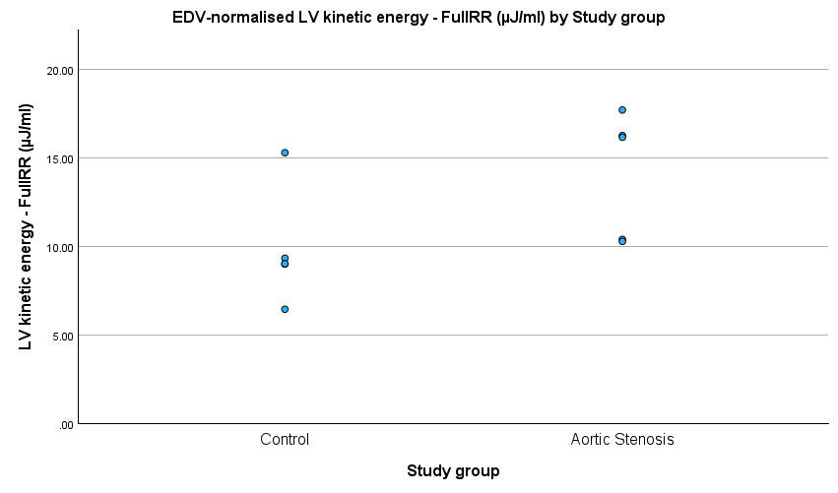
Figure 1 shows the distribution of EDV-normalised LV kinetic energy during the FullRR interval.
[Figure 1. EDV-normalised LV kinetic energy during the FullRR interval in AS and control participants. Points represent individual observations. The between-group comparison was not statistically significant (p = 0.079).]

3.3 LV vorticity
LV vorticity was assessed across the predefined cardiac intervals.
Mean FullRR LV vorticity was higher in the AS group than in controls (315.10 ± 59.91 vs 239.22 ± 27.01 s⁻¹). The mean difference was −75.87 s⁻¹ (95% CI −143.65 to −8.10; p = 0.033; Hedges' g = −1.474).
Systolic LV vorticity was also higher in AS than in controls (308.67 ± 44.46 vs 237.33 ± 34.49 s⁻¹), with a mean difference of −71.34 s⁻¹ (95% CI −129.37 to −13.31; p = 0.022; Hedges' g = −1.619).
The remaining vorticity comparisons were not statistically significant. Diastolic vorticity was 318.38 ± 75.88 s⁻¹ in AS and 245.56 ± 43.53 s⁻¹ in controls (p = 0.100). E-wave vorticity was 317.53 ± 80.54 s⁻¹ and 243.20 ± 17.91 s⁻¹, respectively (p = 0.079), while A-wave vorticity was 319.80 ± 73.30 s⁻¹ and 249.14 ± 105.64 s⁻¹ (p = 0.254). The corresponding 95% CIs were −163.03 to 17.39, −159.42 to 10.76 and −203.26 to 61.95, respectively.
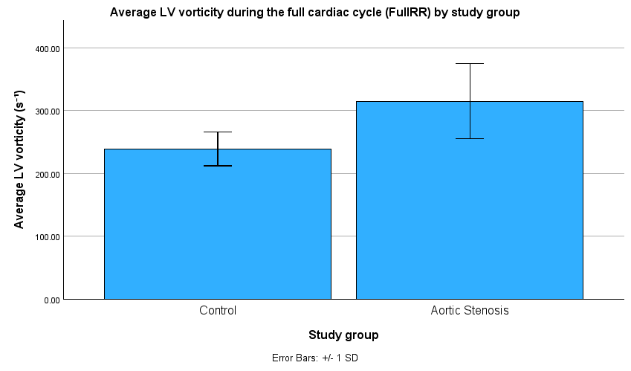
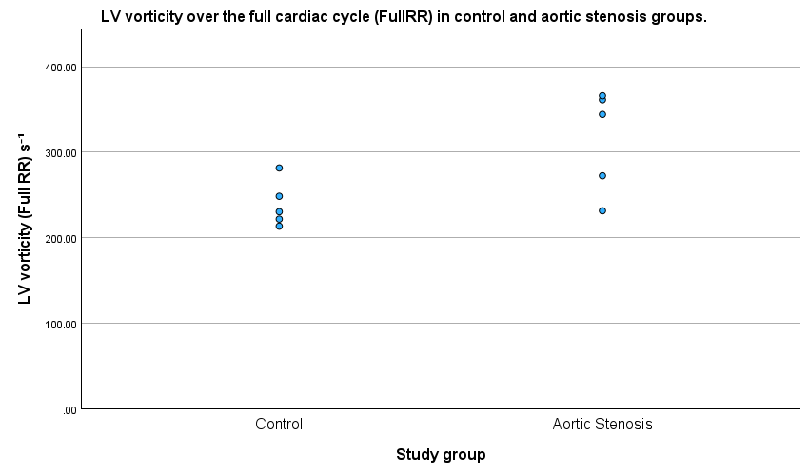
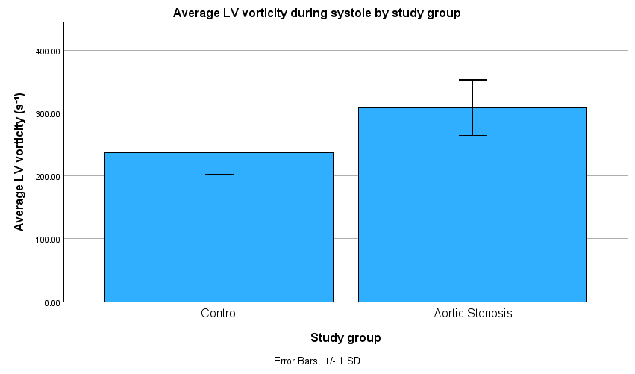
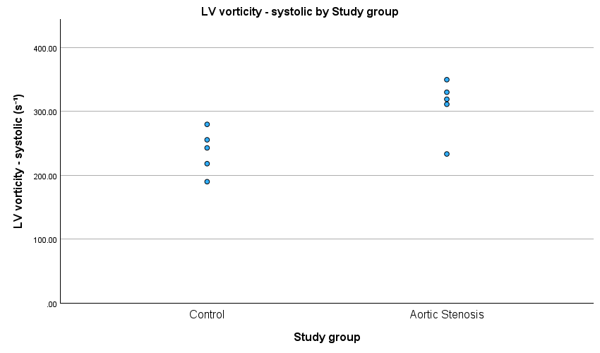
Figure 2 presents the FullRR and systolic LV vorticity comparisons and individual observations.
A
B
C
D
[Figure 2. LV vorticity in AS and control participants. (A) Mean FullRR LV vorticity and (B) mean systolic LV vorticity, with error bars representing ±1 SD. (C) Individual FullRR observations and (D) individual systolic observations. Between-group differences were statistically significant for FullRR (p = 0.033) and systolic (p = 0.022).]

3.4 LV energy loss
LV energy loss was assessed across the predefined cardiac intervals. None of the five comparisons reached the nominal significance threshold of p < 0.05.
Mean FullRR energy loss was 1245.26 ± 729.98 µW in the AS group and 579.85 ± 267.13 µW in controls (p = 0.092). Systolic energy loss was 1203.90 ± 699.58 µW and 599.16 ± 388.59 µW, respectively (p = 0.130).
Diastolic energy loss was 1260.32 ± 744.61 µW in AS and 593.60 ± 265.45 µW in controls (p = 0.096). E-wave energy loss was 1192.73 ± 796.44 µW and 501.42 ± 92.53 µW, respectively (p = 0.090), while A-wave energy loss was 1388.06 ± 676.47 µW and 769.47 ± 634.23 µW (p = 0.174).
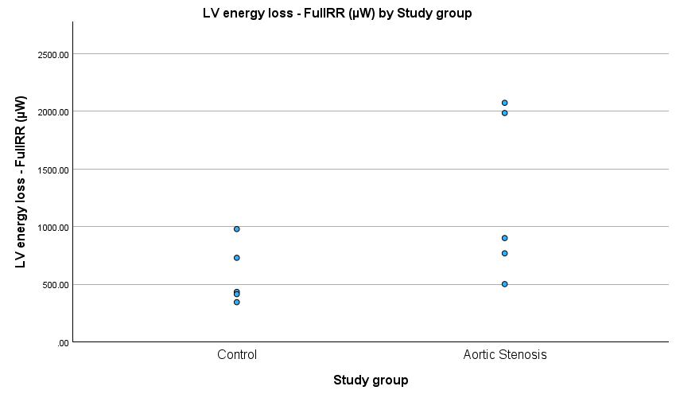
Figure 3 shows the distribution of LV energy loss during the FullRR interval.
[Figure 3. LV energy loss during the FullRR interval in AS and control participants. Points represent individual observations. The between-group comparison was not statistically significant (p = 0.092).]

3.5 Overall flow-energetic findings
Across the three 4D-flow CMR-derived parameters, statistically significant between-group differences were observed only for LV vorticity during FullRR and systole. Mean vorticity was higher in the AS group for both intervals, with p = 0.033 and p = 0.022, respectively.
None of the five EDV-normalised kinetic-energy comparisons or the five energy-loss comparisons reached the nominal significance threshold of p < 0.05.
The Welch unequal-variance sensitivity analysis produced the same significance classification as the primary analysis. FullRR vorticity remained statistically significant with p = 0.045, while systolic vorticity remained statistically significant with p = 0.023. No other comparison changed its statistical significance classification. The primary analysis remains the equal-variance Student's t-test results reported in Table 2.

4. Discussion
4.1 Principal findings
This exploratory retrospective comparative analysis investigated differences in LV flow energetics between five participants with AS and five control participants using 4D-flow CMR. The principal finding was that LV vorticity was significantly higher in the AS group during both the FullRR and systolic intervals. FullRR vorticity was 315.10 ± 59.91 s⁻¹ in AS compared with 239.22 ± 27.01 s⁻¹ in controls, corresponding to a mean difference of −75.87 s⁻¹ (95% CI −143.65 to −8.10; p = 0.033; Hedges' g = −1.474). Systolic vorticity was similarly higher in AS, at 308.67 ± 44.46 s⁻¹ compared with 237.33 ± 34.49 s⁻¹ in controls, with a mean difference of −71.34 s⁻¹ (95% CI −129.37 to −13.31; p = 0.022; Hedges' g = −1.619). Both findings remained statistically significant in the Welch unequal-variance sensitivity analysis (p = 0.045 and 0.023, respectively).
None of the five kinetic-energy comparisons or five energy-loss comparisons reached the nominal significance threshold of p < 0.05. However, the non-significant findings should be interpreted as estimates rather than evidence of absence of an effect. For example, the FullRR energy-loss difference was −665.41 µW, with a 95% CI from −1467.05 to 136.22 µW, illustrating the limited precision of the estimate.
The two significant vorticity findings should not be interpreted as independent confirmations of separate effects. FullRR and systolic vorticity are related measurements derived from the same underlying velocity field, with FullRR encompassing the systolic period. The findings therefore provide convergent evidence of a difference in the measured vorticity parameter across related cardiac intervals rather than two independent observations.
Given the small cohort, the data cannot reliably distinguish a biological difference from sampling variability. The findings should therefore be regarded as exploratory and hypothesis-generating rather than confirmatory.

4.2 LV vorticity
The higher LV vorticity observed during FullRR and systole suggests altered organisation of intracavitary flow in AS. Four-dimensional flow CMR provides time-resolved three-dimensional velocity information that can characterise complex cardiovascular flow patterns beyond conventional scalar haemodynamic measures.⁴ Existing 4D-flow research in AS has predominantly focused on aortic flow and its haemodynamic consequences, whereas quantitative assessment of LV vorticity in AS remains less established.³
The systolic finding is physiologically plausible because AS increases resistance to LV ejection and alters the haemodynamic environment during ventricular outflow. These changes may influence the organisation of intracavitary flow during systole. However, the present analysis cannot establish that AS itself caused the observed increase in vorticity, because ventricular geometry, loading conditions and characteristics of the measured velocity field may also influence this parameter.
A potential segmentation-related source of error was specifically considered. The basal LV contour was positioned to exclude the aortic-valve and LVOT region from the analysed LV volume, reducing the likelihood that inclusion of the high-velocity transvalvular jet or LVOT flow explains the observed systolic finding. The contours were also subsequently reviewed as part of supervisory quality control. However, the available records do not establish whether this review was blinded to group allocation or performed using a formal blinded procedure.
Previous studies provide relevant context. Schäfer et al. reported reduced LV diastolic vorticity in patients with mild-to-moderate COPD, while Demirkiran et al. reported lower mean and peak LV vorticity in patients with chronic myocardial infarction compared with controls.^{11,12} The present observation of higher vorticity in AS therefore differs in direction from these disease-associated reductions. This may reflect differences in disease mechanism, ventricular loading conditions, cardiac phase or study population. These studies support the feasibility of assessing LV vorticity using 4D-flow CMR but do not establish a disease-specific response applicable to AS.
COPD does not provide an alternative explanation for the observed vorticity difference in the present dataset because COPD was absent in all five AS participants and all five controls.¹¹ This removes one specific potential competing explanation, although the small sample size means that the absence of COPD in this cohort does not exclude its relevance in larger AS populations.
Atrial fibrillation represents another important potential confounder. AF was present in one AS participant and two controls, making it more prevalent in the control group. The published PREFER-CMR analysis reported that R-R variability and averaging across multiple heartbeats in AF may affect 4D-flow measurements, including peak-velocity measurements.⁹ Because vorticity depends on spatial velocity gradients, averaging dissimilar cardiac cycles could alter the measured velocity field and potentially attenuate temporal variations in these gradients. The greater prevalence of AF in controls could therefore have contributed to lower measured vorticity in the control group and potentially increased the apparent AS–control difference. This remains speculative because the present study was not designed to quantify the effect of AF on vorticity and no post-hoc subgroup analysis was undertaken.
Stroke volume provides another relevant consideration. Stroke volume was lower in AS than controls (78.2 ± 17.0 versus 88.5 ± 24.3 mL), as was LVEF (46.0 ± 23.3 versus 54.9 ± 4.7%). Kamphuis et al. reported positive associations between stroke volume and vorticity, including strong systolic and diastolic correlations in healthy participants and associations in Fontan patients.¹⁷ Because the group with higher vorticity in the present study had the lower stroke volume, greater flow volume alone is unlikely to explain the observed difference. This reduces one potential alternative explanation but does not establish a causal effect of AS.
Interpretation is also constrained by uncertainty regarding the precise MASS vorticity summary metric. The available documentation does not establish whether the reported regional value represents a peak, volume-integrated or another specific summary formulation. Consequently, the results should be interpreted specifically as the MASS-derived vorticity output used in this analysis rather than assumed to correspond directly to a particular vorticity metric used in other 4D-flow studies.
Technical factors also require consideration. Four-dimensional flow measurements are influenced by acquisition and post-processing characteristics, including spatial resolution, temporal resolution and velocity encoding.⁴ The individual final VENC values were not available for the analysed datasets, although the available project information indicated an initial range of 150–200 cm/s.
The published PREFER-CMR processing pipeline documented screening for aliasing artefacts and manual correction using established phase-unwrapping methods.⁹ However, it was not established whether those specific processing corrections were fully propagated or reproduced during the secondary MASS analysis undertaken here. This distinction is important because the published PREFER-CMR analysis used CVI42, whereas the present secondary analysis used MASS.
Spatial-resolution limitations should also be considered. Previous work has demonstrated sensitivity of 4D-flow-derived energetic measurements to spatial resolution, particularly for viscous energy-loss estimation.⁷ Binter et al. demonstrated that increasing voxel size from 0.625 to 2.5 mm produced substantial underestimation of viscous energy losses under the conditions tested.⁷ The effect of the available acquisition characteristics on the specific MASS-derived vorticity metric used here cannot be quantified, and therefore the magnitude of the vorticity difference should be interpreted cautiously.
Aortic regurgitation provides an additional clinical consideration. AR was recorded as nil in two AS participants and mild in three, with no mild-to-moderate AR recorded. AR status was not available for the control datasets, so its potential contribution to between-group differences cannot be directly assessed.

4.3 EDV-normalised kinetic energy
EDV-normalised kinetic energy was numerically higher in the AS group across all five cardiac intervals, although none of the comparisons reached statistical significance. FullRR kinetic energy was 14.15 ± 3.54 µJ/mL in AS compared with 9.82 ± 3.27 µJ/mL in controls (p = 0.079). Similar numerical differences were observed during systole, diastole, E-wave and A-wave.
The direction of these findings is of interest because previous work has demonstrated relationships between LV blood-flow kinetic energy, functional capacity and LV remodelling in AS. Elhawaz et al. investigated LV blood-flow kinetic energy in patients with AS undergoing valve intervention and reported associations with the six-minute walk test and subsequent LV remodelling.¹⁰ The present study differs from that work in its exploratory case–control design, small sample size and use of EDV-normalised kinetic energy across predefined cardiac intervals rather than longitudinal assessment following intervention.
The absence of statistical significance should not be interpreted as evidence that kinetic energy is unchanged in AS. The small sample size provides limited statistical power and several estimates had substantial uncertainty. The consistent numerical direction across all five intervals may therefore warrant investigation in larger cohorts. However, the absence of multiplicity correction and the exploratory design mean that these observations remain hypothesis-generating.
The LV volume measurements provide additional context. Mean LV EDV was 230.8 ± 170.2 mL in AS compared with 160.8 ± 39.3 mL in controls. Thus, the AS group had a larger mean LV volume despite substantial variability. Because kinetic energy was normalised to EDV, the higher numerical kinetic-energy values in AS cannot simply be attributed to the larger LV volume denominator. Indeed, higher EDV-normalised kinetic energy was observed despite the larger mean EDV in the AS group. Nevertheless, the marked variability in LV volume means that the relationship between ventricular size and normalised kinetic energy remains uncertain.
Papillary-muscle treatment represents another methodological consideration. Papillary muscles were included within the LV endocardial contour and therefore within the LV blood-pool region used for analysis. This differs from previous 4D-flow CMR work in AS in which papillary muscles were excluded.¹⁰ Inclusion of papillary muscles may alter the defined blood-pool volume and consequently the EDV denominator used for kinetic-energy normalisation. Because ventricular morphology may differ between groups, the magnitude and direction of any resulting group asymmetry cannot be determined from the present data.

4.4 Energy loss
Energy loss was numerically higher in the AS group across all five intervals, but none of the comparisons reached statistical significance. FullRR energy loss was 1245.26 ± 729.98 µW in AS compared with 579.85 ± 267.13 µW in controls, with a mean difference of −665.41 µW (95% CI −1467.05 to 136.22; p = 0.092). Similar numerical differences were observed during systole, diastole, E-wave and A-wave.
The consistently higher energy-loss measurements in AS may indicate altered intracavitary flow organisation and increased energy dissipation, but the confidence intervals were wide and crossed zero. The findings therefore do not establish a statistically significant difference or demonstrate equivalence between groups.
Unlike kinetic energy, the energy-loss parameter was not normalised to LV EDV in the present analysis. This is relevant because the AS group had a larger mean LV EDV than controls (230.8 ± 170.2 versus 160.8 ± 39.3 mL). Consequently, the higher absolute energy-loss values observed in AS may partly reflect differences in ventricular volume rather than greater energy dissipation per unit volume. The present data cannot separate these effects, and future studies should consider both absolute and volume-normalised energy-loss measures.
Interpretation is further limited because the exact mathematical formulation implemented by the MASS energy-loss parameter could not be independently established from the available project documentation. The parameter was therefore retained using the MASS-generated terminology rather than being reclassified as viscous energy loss or turbulent kinetic energy. Comparisons with studies using differently defined energy-loss metrics should consequently be made cautiously.
Previous 4D-flow studies have demonstrated that energetic measurements can provide information about the haemodynamic consequences of AS. Dyverfeldt et al. demonstrated a relationship between aortic turbulent kinetic energy and irreversible pressure loss in AS, while Binter et al. subsequently showed that turbulent kinetic energy could provide additional information relative to conventional echocardiographic measures of AS severity.^{13,14} These studies examined aortic rather than LV flow and used different energetic metrics from the MASS-derived parameter used here. They therefore provide physiological context rather than direct reference ranges for the present measurements.
Spatial resolution is particularly relevant to energy-loss estimation. Binter et al. demonstrated that increasing voxel size from 0.625 to 2.5 mm resulted in substantial underestimation of viscous energy losses under the conditions tested.⁷ The present study did not have sufficient acquisition documentation to determine the precise spatial-resolution characteristics of the analysed datasets. Absolute energy-loss values should therefore be interpreted cautiously, particularly when comparing them with studies using different acquisition and analysis methods.

4.5 Strengths and limitations
A major strength of this study is that it provides an exploratory assessment of multiple LV flow-energetic parameters across several cardiac intervals within an existing CMR research dataset. The analysis used the same predefined approach across the AS and control datasets and applied consistent LV contouring and MASS-based processing. Stroke volume and LVEF were also examined, providing useful context for interpreting the vorticity findings.
The availability of a control arm is also a strength compared with studies that evaluate LV flow energetics within AS without a comparator group. However, the control cohort should not be interpreted as a uniformly healthy volunteer population. Two controls had AF, two had oedema and two were recorded as NYHA class II.
The baseline characteristics demonstrated important between-group imbalance. The AS participants were older than the controls, with mean ages of 73.6 ± 9.6 and 57.6 ± 17.0 years, respectively. Hypertension was present in four of five AS participants compared with none of the controls, while IHD was present in two AS participants and none of the controls. These differences represent potential confounding factors because age and cardiovascular comorbidity may influence ventricular structure, function and intracavitary flow independently of AS. Given the sample size, reliable statistical adjustment for these factors was not possible and was not undertaken.
The AS haemodynamic measurements also demonstrated cross-modality discordance between CMR- and echocardiographic-derived valve measurements in two participants. The available CMR peak velocity, echocardiographic peak velocity, mean transvalvular gradient and AVA measurements were therefore reported descriptively rather than used to assign a single categorical AS severity classification. The absence of an independent contemporaneous reassessment means that AS severity cannot be treated as a precisely defined explanatory variable in the present analysis. Severity was also not used as an eligibility criterion, selection criterion or stratification variable.
The analysed datasets were selected from a larger available pool under the practical constraints of the dissertation. Ten control datasets were available and five were analysed, while five AS datasets were selected from the wider available AS dataset. The precise historical selection mechanism could not be independently established and was not described as random, consecutive or formally matched. This introduces potential selection bias and limits the representativeness of the analysed sample.
Although both groups originated from the same PREFER-CMR registry, the operational basis for control status could not be independently verified from the data available to the researcher. No valve-related measurements were available for the control datasets, including CMR or echocardiographic peak velocity, mean transvalvular gradient, AVA or AR status. Consequently, the absence of AS in the control group could not be independently re-established in the present analysis and rests on the registry group assignment. This limits certainty regarding comparator status and should be addressed explicitly in future registry analyses.
The study was conducted using datasets from a single-centre registry at NNUH. The single-centre nature of the dataset may limit generalisability to other populations, institutions, scanners and acquisition protocols.
The five AS datasets formed part of the cohort reported in the published PREFER-CMR study.⁹ The present analysis therefore represents a secondary analysis rather than an independently recruited replication cohort. The published study focused on aortic haemodynamic measures, whereas the present analysis examined LV flow-energetic parameters. This provides a complementary analysis of the existing registry data but means that the AS cohort should not be considered an independent replication sample.
The researcher was aware of group allocation during contour review. Dr Rui Li subsequently performed quality-control review, but the available records do not establish whether this review was blinded to group allocation or whether all ten datasets were reviewed using a formal blinded procedure. No formal intra-observer or inter-observer reproducibility assessment was undertaken. Previous work demonstrated scan–rescan reproducibility of LV kinetic energy, viscous energy loss and vorticity during diastolic filling in healthy subjects, but this does not establish reproducibility of the present FullRR or systolic vorticity measurements in AS.⁸
AI-assisted contouring was initially used to generate LV contours, followed by manual review and correction. Although this provided an efficient starting point for segmentation, differences in contour placement may influence the LV region included in the flow analysis. Papillary muscles were consistently included within the LV endocardial contour, differing from some previous 4D-flow CMR work in AS.¹⁰ This may influence the defined LV volume and the derived energetic measurements. Because ventricular morphology may differ between groups, the magnitude and direction of any resulting group asymmetry cannot be determined from the present data.
Finally, the parent registry's published analysis and the present secondary analysis used different post-processing environments. The published PREFER-CMR analysis used CVI42, whereas the present analysis used MASS. Although the same underlying 4D-flow datasets were analysed, differences between software platforms may affect derived flow-energetic parameters. The present study therefore provides an exploratory analysis rather than a software-independent validation of LV flow-energetic measurements.
4.6 Implications and future research
The present findings support further investigation of LV vorticity as a potential marker of altered intracavitary flow in AS. However, the current evidence is insufficient to support its use as a disease-specific or clinically applicable biomarker. Future studies should use substantially larger cohorts with prospectively defined inclusion and exclusion criteria, clearly defined control status and standardised CMR acquisition and post-processing protocols.
Future registry analyses should explicitly document the eligibility criteria and operational definition of the control arm, including how absence of AS is established. This would reduce uncertainty arising from reliance on dataset assignment and improve comparability between groups. Multicentre recruitment would also improve generalisability and reduce the influence of centre-specific acquisition and processing practices.
Future studies should prospectively record complete acquisition and processing histories, including dataset-specific VENC, spatial and temporal resolution, and the handling of aliasing and phase-unwrapping corrections. Where secondary analyses are undertaken, the propagation of these processing steps from the parent pipeline into the software used for re-analysis should be explicitly documented.
Standardised contouring protocols should be established before analysis, including predefined conventions for papillary-muscle treatment and basal LV/LVOT boundaries. AI-assisted segmentation may improve efficiency, but its use should be accompanied by systematic quality-control procedures and formal intra- and inter-observer reproducibility assessment.
The relationship between LV vorticity, ventricular volumes, stroke volume, LVEF and clinical measures should also be investigated in larger cohorts. Longitudinal studies could determine whether changes in LV flow energetics accompany disease progression or change following aortic-valve intervention.
The non-invasive pressure–volume loop component originally proposed for this project was not completed within the dissertation timeframe and should be considered in future work. Pressure-volume-derived measures such as stroke work and pressure-volume area describe myocardial mechanical energetics, whereas 4D-flow-derived kinetic energy, vorticity and energy-loss measures describe blood-flow energetics.¹⁵ Combining these complementary domains may provide a more comprehensive assessment of ventricular mechanical efficiency and intracavitary flow behaviour rather than treating them as interchangeable measures.
Future work should also investigate the influence of rhythm, particularly AF, on phase-specific 4D-flow measurements. Analyses stratified by rhythm or using standardised beat-selection and averaging approaches may help determine whether the observed vorticity differences persist after accounting for R-R variability.

4.7 Conclusion
This exploratory analysis identified higher LV vorticity in participants with AS during the FullRR and systolic intervals, while EDV-normalised kinetic energy and energy loss were numerically higher but not statistically significantly different across the assessed cardiac intervals. The findings partially support the study hypothesis and suggest that LV vorticity may capture alterations in intracavitary flow that are not explained solely by stroke volume or LVEF.
However, the small sample, baseline age and comorbidity imbalance, potential selection bias, clinical heterogeneity of the control cohort, inability to independently verify the absence of AS in the control datasets, single-centre provenance, technical uncertainties, methodological differences between CVI42 and MASS, lack of formal reproducibility assessment and lack of multiplicity correction substantially limit inference.
The FullRR and systolic vorticity findings should therefore be regarded as related exploratory observations rather than independent confirmations of a disease-specific effect. The present findings do not establish LV vorticity as a disease-specific or clinically applicable marker of AS. Larger, prospectively designed, multicentre studies with clearly defined control eligibility, standardised acquisition and processing, and formal reproducibility assessment are required to determine whether LV vorticity provides reproducible and clinically meaningful information in AS.

References:
1. Vahanian A, Beyersdorf F, Praz F, Milojevic M, Baldus S, Bauersachs J, et al. 2021 ESC/EACTS Guidelines for the management of valvular heart disease. European Heart Journal. 2022 Feb 12;43(7):561–632. doi:10.1093/eurheartj/ehab395
2. Parameswaran AC, Reisner D, Amanullah A. Discrepancy between gradients derived by cardiac catheterization and by Doppler echocardiography in aortic stenosis: how often does pressure recovery play a role? Echocardiography. 2009 Oct;26(9):1000–5; quiz 999. doi:10.1111/j.1540-8175.2009.00909.x PubMed PMID: 19840067.
3. Garcia J, Barker AJ, Markl M. The Role of Imaging of Flow Patterns by 4D Flow MRI in Aortic Stenosis. JACC: Cardiovascular Imaging. 2019 Feb;12(2):252–66. doi:10.1016/j.jcmg.2018.10.034
4. Dyverfeldt P, Bissell M, Barker AJ, Bolger AF, Carlhäll CJ, Ebbers T, et al. 4D flow cardiovascular magnetic resonance consensus statement. Journal of Cardiovascular Magnetic Resonance. 2015 Jan;17(1):72. doi:10.1186/s12968-015-0174-5
5. Adriaans BP, Westenberg JJM, Van Cauteren YJM, Gerretsen S, Elbaz MSM, Bekkers SCAM, et al. Clinical assessment of aortic valve stenosis: Comparison between 4D flow MRI and transthoracic echocardiography. Magnetic Resonance Imaging. 2020 Feb;51(2):472–80. doi:10.1002/jmri.26847
6. Archer GT, Elhawaz A, Barker N, Fidock B, Rothman A, van der Geest RJ, et al. Validation of four-dimensional flow cardiovascular magnetic resonance for aortic stenosis assessment. Sci Rep. 2020 Jun 29;10(1):10569. doi:10.1038/s41598-020-66659-6 PubMed PMID: 32601326; PubMed Central PMCID: PMC7324609.
7. Binter C, Gülan U, Holzner M, Kozerke S. On the accuracy of viscous and turbulent loss quantification in stenotic aortic flow using phase-contrast MRI. Magn Reson Med. 2016 Jul;76(1):191–6. doi:10.1002/mrm.25862 PubMed PMID: 26258402.
8. Kamphuis VP, Westenberg JJM, Van Der Palen RLF, Van Den Boogaard PJ, Van Der Geest RJ, De Roos A, et al. Scan–rescan reproducibility of diastolic left ventricular kinetic energy, viscous energy loss and vorticity assessment using 4D flow MRI: analysis in healthy subjects. Int J Cardiovasc Imaging. 2018 Jun;34(6):905–20. doi:10.1007/s10554-017-1291-z
9. Grafton-Clarke C, Assadi H, Li R, Mehmood Z, Hall R, Matthews G, et al. Four-dimensional flow provides incremental diagnostic value over echocardiography in aortic stenosis. Open Heart. 2025 Jan;12(1):e003081. doi:10.1136/openhrt-2024-003081
10. Elhawaz A, Archer GT, Zafar H, Fidock B, Barker N, Jones R, et al. Left ventricular blood flow kinetic energy is associated with the six-minute walk test and left ventricular remodelling post valvular intervention in aortic stenosis. Quant Imaging Med Surg. 2021 Apr;11(4):1470–82. doi:10.21037/qims-20-586
11. Schäfer M, Humphries S, Stenmark KR, Kheyfets VO, Buckner JK, Hunter KS, et al. 4D-flow cardiac magnetic resonance-derived vorticity is sensitive marker of left ventricular diastolic dysfunction in patients with mild-to-moderate chronic obstructive pulmonary disease. Eur Heart J Cardiovasc Imaging. 2018 Apr 1;19(4):415–24. doi:10.1093/ehjci/jex069 PubMed PMID: 28460004; PubMed Central PMCID: PMC6279084.
12. Demirkiran A, Hassell MECJ, Garg P, Elbaz MSM, Delewi R, Greenwood JP, et al. Left ventricular four-dimensional blood flow distribution, energetics, and vorticity in chronic myocardial infarction patients with/without left ventricular thrombus. Eur J Radiol. 2022 May;150:110233. doi:10.1016/j.ejrad.2022.110233 PubMed PMID: 35278980.
13. Dyverfeldt P, Hope MD, Tseng EE, Saloner D. Magnetic Resonance Measurement of Turbulent Kinetic Energy for the Estimation of Irreversible Pressure Loss in Aortic Stenosis. JACC: Cardiovascular Imaging. 2013 Jan;6(1):64–71. doi:10.1016/j.jcmg.2012.07.017
14. Binter C, Gotschy A, Sündermann SH, Frank M, Tanner FC, Lüscher TF, et al. Turbulent Kinetic Energy Assessed by Multipoint 4-Dimensional Flow Magnetic Resonance Imaging Provides Additional Information Relative to Echocardiography for the Determination of Aortic Stenosis Severity. Circ: Cardiovascular Imaging. 2017 Jun;10(6):e005486. doi:10.1161/CIRCIMAGING.116.005486
15. Knaapen P, Germans T, Knuuti J, Paulus WJ, Dijkmans PA, Allaart CP, et al. Myocardial Energetics and Efficiency: Current Status of the Noninvasive Approach. Circulation. 2007 Feb 20;115(7):918–27. doi:10.1161/CIRCULATIONAHA.106.660639
16. Seemann F, Arvidsson P, Nordlund D, Kopic S, Carlsson M, Arheden H, et al. Noninvasive Quantification of Pressure-Volume Loops From Brachial Pressure and Cardiovascular Magnetic Resonance. Circ Cardiovasc Imaging. 2019 Dec;12(1):e008493. doi:10.1161/CIRCIMAGING.118.008493 PubMed PMID: 30630347.
17. Kamphuis VP, Roest AAW, Van Den Boogaard PJ, Kroft LJM, Lamb HJ, Helbing WA, et al. Hemodynamic interplay of vorticity, viscous energy loss, and kinetic energy from 4D Flow MRI and link to cardiac function in healthy subjects and Fontan patients. American Journal of Physiology-Heart and Circulatory Physiology. 2021 Apr 1;320(4):H1687–98. doi:10.1152/ajpheart.00806.2020

